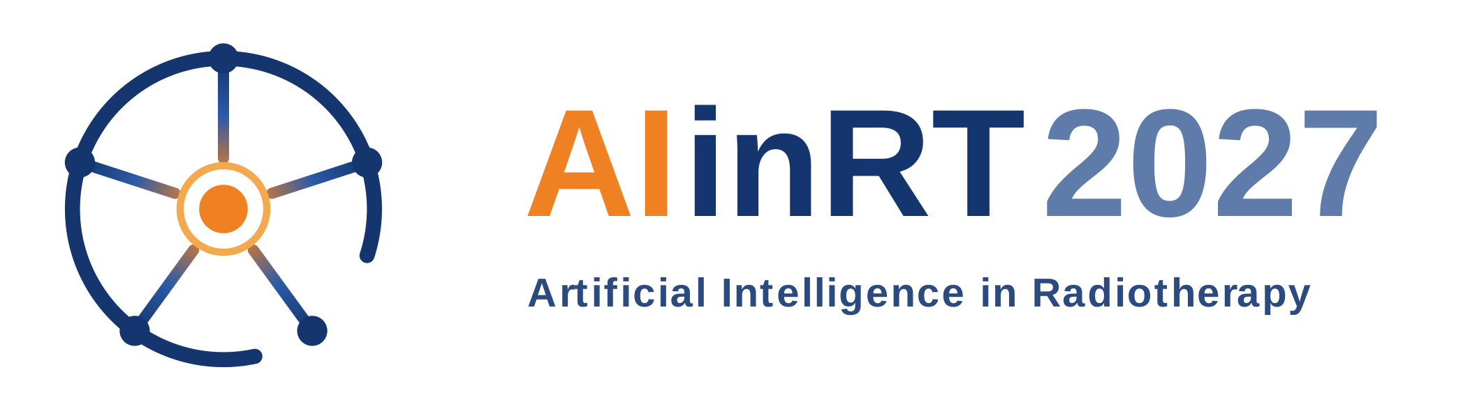
PRE-ANNOUNCEMENT · CALL FOR ABSTRACTS
Peer-reviewed science on AI
across the radiotherapy workflow
AIinRT2027 is a two-day, fully double blind peer-reviewed symposium on artificial intelligence in radiotherapy: segmentation & registration, reconstruction & synthesis, foundation models & explainability, dose & adaptive workflows, clinical predictions & outcomes, and implementation, QA & ethics — with expert state-of-the-art talks, proffered papers, and cross-disciplinary keynotes.
Dates | 1–2 April 2027 (Thursday–Friday)
Venue | UMC Utrecht & Princess Máxima Center, Utrecht, the Netherlands

Key dates
1 Sep 2026 | Abstract submission opens
1 Oct 2026 | Registration opens
1 Dec 2026 | Abstract submission deadline
17 Dec 2026 | Abstract decisions communicated
1 Mar 2027 | Registration closes
1–2 Apr 2027 | AIinRT 2027 Symposium, Utrecht

Visit https://AIinRT.org — Call for Abstracts opens on 1 September

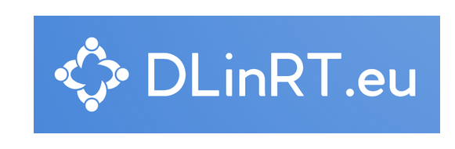
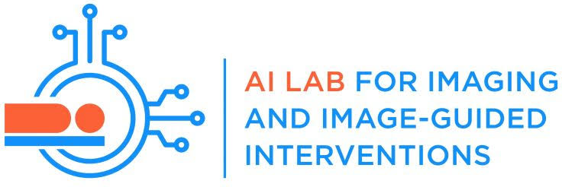
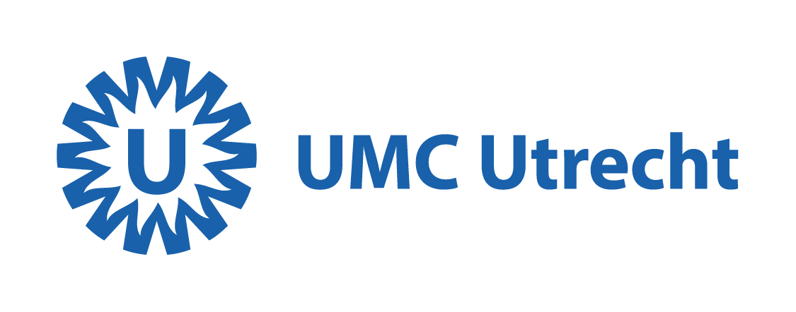
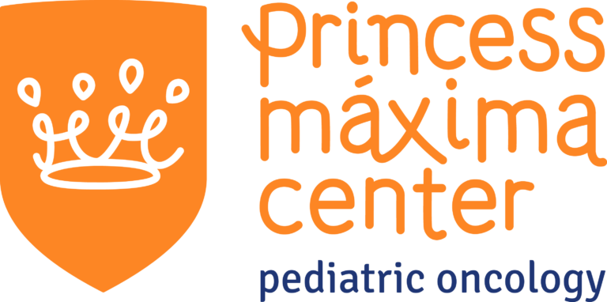
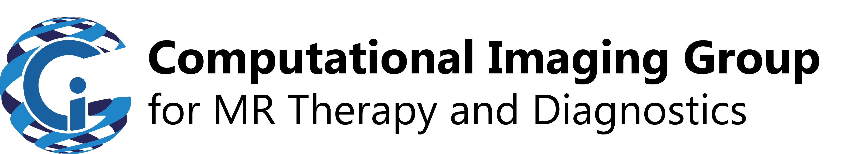
Organised by UMC Utrecht and the Computational Imaging Group, in collaboration with the Princess Máxima Center, DLinRT.eu, and the AI Lab for Imaging and Image-Guided Interventions

